NETWORK TOPOLOGY IN PACKET TRACER

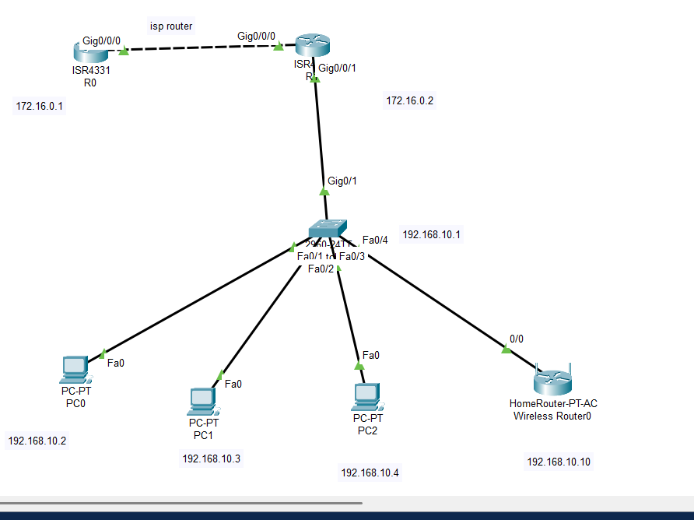1. ISP Router (R0)
Enable
configure terminal
interface gig0/0/0
ip address 172.16.0.1 255.255.255.0
no shutdown
exit

interface loopback0
ip address 8.8.8.8 255.255.255.255
exit
ip route 192.168.10.0 255.255.255.0 172.16.0.2

• Sets up WAN link to LAN router and static route to company’s LAN for response traffic.

2.LAN Router (R1)

enable
configure terminal
interface gig0/0/0
ip address 172.16.0.2 255.255.255.0
no shutdown
exit

interface gig0/0/1
ip address 192.168.10.1 255.255.255.0
no shutdown
exit

ip route 0.0.0.0 0.0.0.0 172.16.0.1

• Configures LAN/WAN interfaces and a default static route to ISP router.

3. NAT Configuration on R1

access-list 1 permit 192.168.10.0 0.0.0.255
interface gig0/0/0
ip nat outside
exit
interface gig0/0/1
ip nat inside
exit
ip nat inside source list 1 interface gig0/0/0 overload

• Sets up dynamic NAT with overload, mapping multiple local addresses to the external interface

PC Connectivity:

•Use ping 192.168.10.1 from PCs to ensure gateway access.
•Use ping 8.8.8.8 to verify Internet access via NAT.

Show commands on routers:

•show ip interface brief (interface status)
•show ip route (routing table)
•show ip nat translations (NAT operation verification)

NOTE: KINDLY ERASE THE CONFIGURATION IN THE ROUTER AND SWITCH WHEN YOU WORKING ON REALTIME PROJECT. D

